Tuesday 4th November 2025
All Together Against Bullying Week 2025 at Priory Junior School

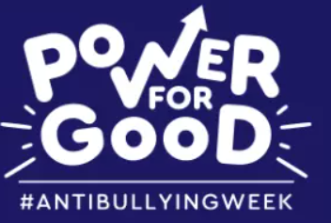

Anti-bullying Week 2025 will take place from Monday 10th to Friday 14th November, with the theme:

“Power for Good.”

Odd Socks Day will launch the week on Monday 10th November, with adults and children encouraged to wear odd socks all week to celebrate what makes us all unique.

There’s a powerful message behind the socks, “Let’s pull on odd socks to show we’re ALL different and let’s use our power for good by being kind, supportive, and respectful of one another.”

The Anti-Bullying Alliance defines bullying as:

“The repetitive, intentional hurting of one person or group by another person or group, where the relationship involves an imbalance of power.”

Throughout the week, children at Priory will explore what this means in practice through focused lessons, assemblies, and creative activities. They will reflect on how their own words and actions have the power to affect others — and how they can use that power in positive ways.

The theme “Power for Good” encourages everyone to recognise that we all have the ability to make a difference. Whether it’s defending someone who needs help, showing kindness, or spreading positivity online, small actions can have a powerful and lasting impact.

During Anti-Bullying Week, children will explore the language and concepts we use when talking about bullying to help them understand it clearly and confidently.

One key word they will focus on is “Defending”, which means resisting an attack made on someone or something, and protecting others from harm or danger.
Children will discuss how to defend safely and calmly — learning that standing up for someone does not mean retaliating or responding with anger, but instead using words, actions, or seeking adult support to make a positive difference.

They will also learn about the different roles people can play in bullying situations. It is not simply a case of a “bully” and a “victim,” but a wider group dynamic that can include:

- Defenders – those who defend others by seeking adult help, show kindness and empathy.
- Outsiders – those who witness bullying and don’t get involved.
- Reinforcers – those who may join in or encourage unkind behaviour.

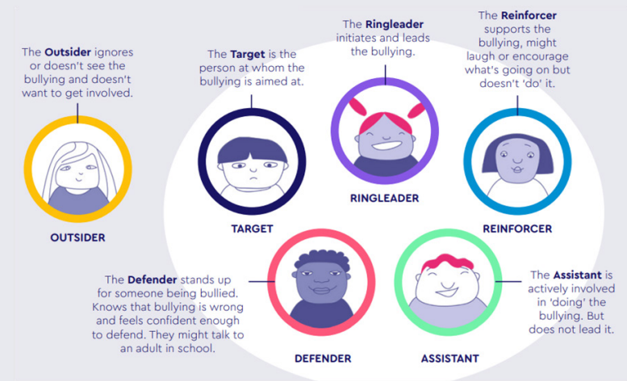
By recognising these roles, children can better understand how their own choices and voices matter — and how they can use their Power for Good to make Priory Junior School a safe and respectful place for everyone.

Children will learn the difference between relational conflict and bullying:

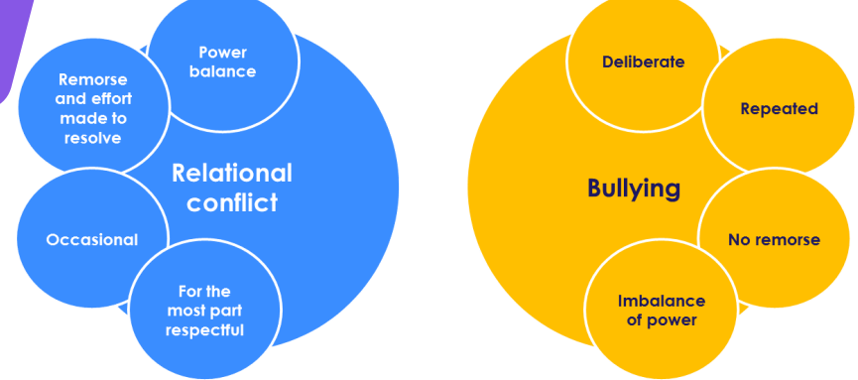

This year, we’ll be empowering children and young people to:

- Recognise their own power to defend against bullying and injustice.
- Use their voices to support others and promote respect.
- Understand that adults and peers alike can be role models who use their influence for good — both in person and online.

From playgrounds to classrooms, our homes to our phones, let’s use our “Power for Good” to make a lasting difference and help create a community where everyone feels safe, respected, and valued.
Imagine a world where kindness and empathy thrive — it starts with each of us. Join us this Anti-Bullying Week as we commit to using our Power for Good.

For more information and resources, please visit our Priory Junior School Anti-Bullying Parent Hub:
Priory Junior School - United Against Bullying

Yours sincerely,
Miss H Edwards
Deputy Head Teacher

