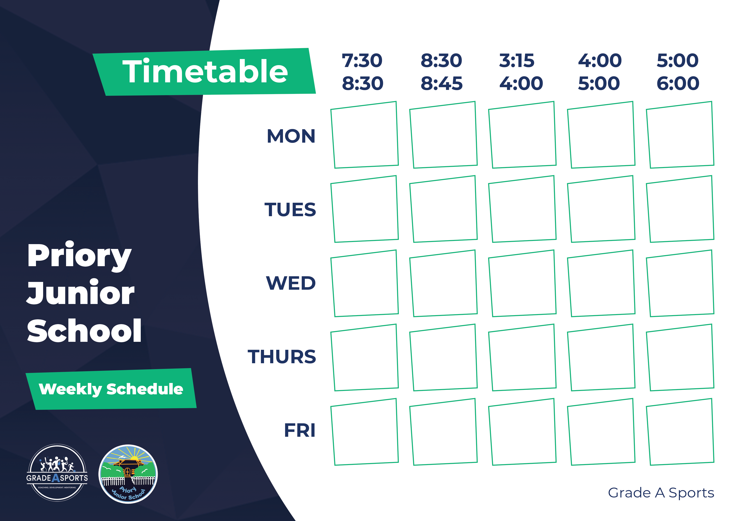

Dodge Ball

Outdoor Adventure

Joe Wicks wake up

Outdoor Play

Tag Games

Mini yoga

Arts and Crafts

Lego Club

Film Club
Coloring Club
Board Games
Super movers
Jacket Potato
Clay Model Making
Football
Circle Games
Roast Chicken Dinner
Fossil Hunt

Laser Tag
Fish Finger Wraps
Rocket league (RC Cars)
Hot Dogs and French Fries
Dragons Den Smoothies
Board Games
Tomato Pasta

