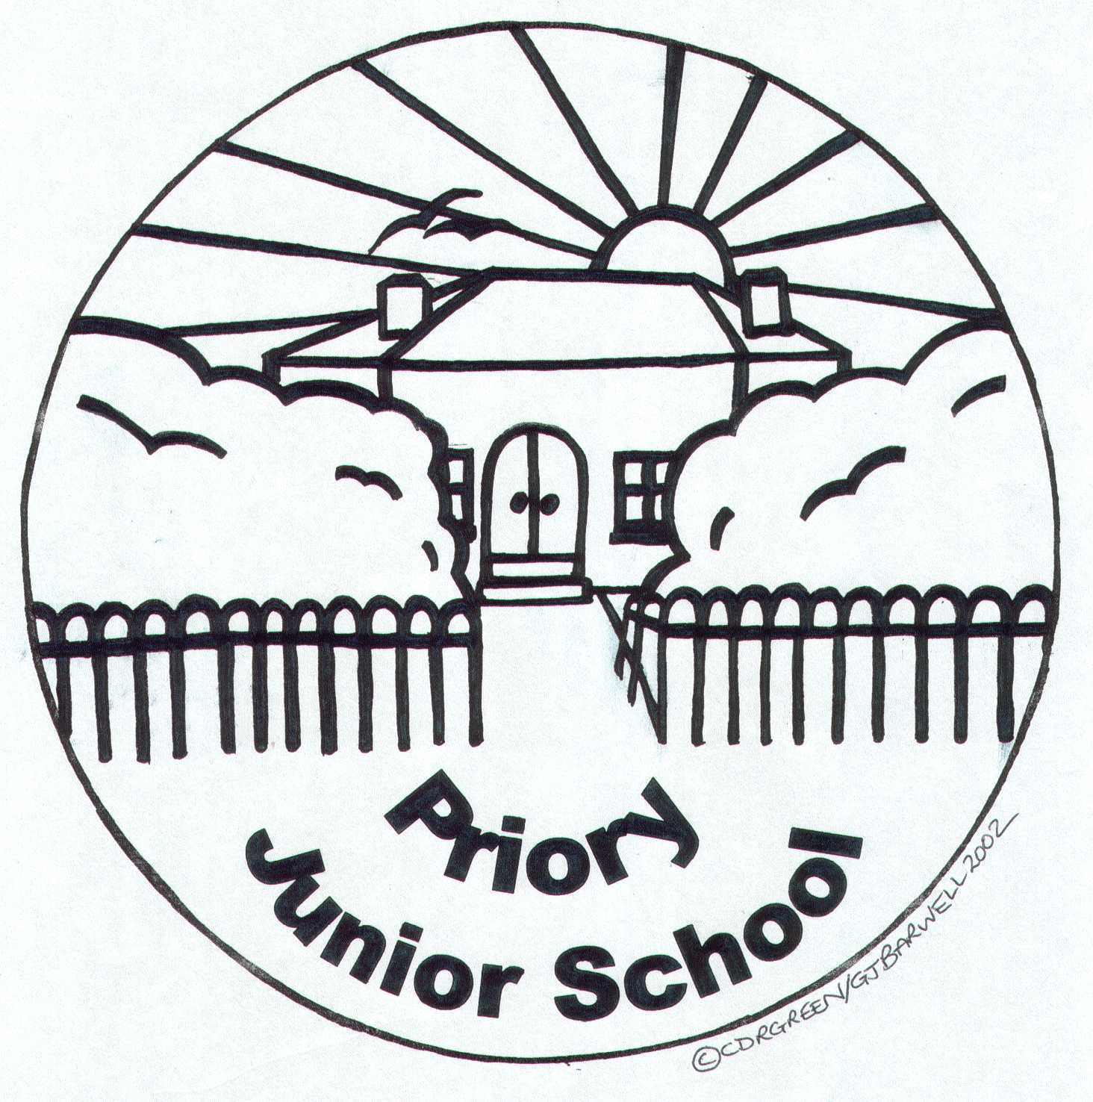

ANTI-BULLYING POLICY

Updated Autumn 2022

(This policy was devised to comply with the specifications for the All Together United against Bullying Project 2020-2021 and uses Nottinghamshire County Council’s policy template 2022-2023)

Date approved by the ‘D and P’ Committee

Signed by Chair of Governors: ...………………………………………………..

Signed by Head Teacher: ……………………………………………….

Date of next review Autumn 2024
Our Ethos and Values

At Priory Junior School we believe that our children need to be equipped with skills that will help to prepare them for modern life in a digital age. We aim to develop the whole child through the learning we provide and the PRIDE values that we adhere to.

- We want our children to be at PEACE with themselves and live in peace with others
- We want our children to RESPECT themselves and celebrate diversity
- We want our children to grow in confidence, learn INDEPENDENCE; take responsibility for themselves and act responsibly in society
- We want our children to show DETERMINATION and resilience in their relationships
- We want our children to be ambassadors of justice, challenge prejudice and value EQUALITY.

At Priory Junior School we aim to provide a supportive, caring, and friendly environment which allows all our pupils to learn in an atmosphere which is focussed on improving their life chances and helping them to maximise their potential. We expect our pupils to act safely, and feel safe, in and outside of school – we do not tolerate any form of bullying and we are committed to preventing and tackling it. We recognise that as children learn and grow together, they may experience fallouts with their peers, but we are committed to supporting our pupils to resolve these ‘relational conflicts’ and stop them from progressing to bullying behaviours. If an incident of bullying does occur, we believe our pupils, parents/carers and staff should feel confident in reporting it and know that that all incidents will be dealt with promptly and effectively. Bullying will never be tolerated at our school.

At Priory Junior School we encourage open discussions around differences between people, we actively challenge prejudice, and we celebrate diversity. We adopt a contextual safeguarding, trauma-informed and strengths-based approach to bullying and child-on-child abuse, and we are committed to working with families and outside agencies where appropriate.

Policy Development

This policy has been developed to reflect the most recent Keeping Children Safe in Education (KCSiE) Statutory Guidance (1st September 2022) and was formulated in consultation with the whole school community with input from:

- Members of staff - reviews at staff briefings and meetings following inspections or monitoring
- Governors - discussions at governors’ meetings
- Children and young people - pupils contribute to the development of the policy through the school Parliament team, Priory Peace Force, and class debates during Parliament week etc.
- Anti-Bullying Alliance ‘All Together’ project (Gold Award 2021) and guidance from Nottinghamshire County Council.

This policy is available:

- School website United Against Bullying - Priory Junior School (priory-jun.notts.sch.uk)
- From the school office via email
- Shorter child friendly versions via the website

Roles and responsibilities

The Head Teacher has overall responsibility for the policy and its implementation and liaising with the governing body, parents/carers, LA and outside agencies and appointing an Anti-bullying coordinator who will have general responsibility for handling the implementation of this policy.

The Anti-bullying Coordinator in our school is: Holly Edwards (DH)

The responsibilities are:
- Policy development and review involving pupils, staff, governors, parents/carers and relevant local agencies
- Implementing the policy and monitoring and assessing its effectiveness in practice
- Ensuring evaluation takes place and that this informs policy review
- Managing bullying incidents
- Managing the reporting and recording of bullying incidents
- Assessing and coordinating training and support for staff and parents/carers where appropriate
- Coordinating strategies for preventing bullying behaviour

There is a nominated Governor with the responsibility for Anti-bullying (Behaviour and RSHE).

The Designated Safeguarding Leads (DSL) and their Deputy Safeguarding lead in our school are: Alison Prodger (DSL), Holly Edwards (DSL) and Catherine Clark (DDSL). Safeguarding is the responsibility of all, however all staff, parents/carers and pupils need to be aware of who to report to and how to report any safeguarding concerns.

Definition of Bullying

At Priory we have adopted the definition of bullying provided by the Anti-Bullying Alliance:

Bullying is the repetitive, intentional hurting of one person or group by another person or group, where the relationship involves an imbalance of power. Bullying can be physical, verbal or psychological. It can happen face-to-face or through cyberspace.

www.anti-bullyingalliance.org.uk/tools-information/all-about-bullying/what-bullying/aba-definition-bullying

How does it differ to relational conflict?

We recognise that bullying can take many forms and can affect any child. It is often motivated by prejudice against particular groups (for example on grounds of race, religion, gender, sexual orientation, special educational needs, or disabilities, or because a child is adopted, in care or has caring responsibilities). Bullying can be motivated by actual differences between children, or perceived differences.

However, we also recognise that incidents may occur between pupils, which may not be deemed as ‘bullying’ but still require support or intervention from trusted adults. These incidents may be referred to as ‘relational conflicts’ or falling out. Relational conflict differs to bullying in the fact that it is usually between individuals or groups who are relatively similar in power and status (a power balance), and the behaviours or incidents occur occasionally (not repetitive) or occur by accident (not intentional). Usually, following a relational conflict incident, pupils show remorse and there is a general willingness to make things right or to resolve the conflict.

Not all relational conflict or falling out leads to bullying, but our school is aware occasionally some can, and we are mindful that unresolved bad feelings or relationship problems left unaddressed can be the start of a pattern of behaviour in which the intention becomes to cause harm or distress.

Although bullying and relational conflicts can take place between individuals, we recognise that it often takes place in front of others (either physically or virtually), pupils who witness these incidents/behaviours are often referred to as ‘Outsiders’ (bystanders).

Regardless of whether an incident or situation is deemed as ‘relational conflict’ or ‘bullying’, our school will address the situation and support the pupils to resolve any negative feelings. Our school will monitor children following a relational conflict to ensure that the situation has been resolved and does not escalate to bullying. Our school will challenge, address, and monitor any incidents of bullying, to ensure that it does not continue and that all pupils feel supported (this will include the target, the alleged perpetrator, any outsiders/bystanders, and the wider school community

Behaviour often associated with bullying:

Baiting

Baiting can be used in bullying both on and offline. It can be used to bully someone to get 'a rise' out of them and it can be used to antagonize those who might be bullying others to get them to bully. Sometimes baiting is used secretively to try and get a person to explode in a rage or react negatively/loudly so that they get in to trouble.

Banter

The dictionary describes banter as: ‘the playful and friendly exchange of teasing remarks’.
Bullying is often justified as being just banter. It may start as banter, but some types of banter are bullying and need to be addressed as bullying.

Types of Banter:

- Friendly Banter - there’s no intention to hurt and everyone knows its limits
- Ignorant Banter - crosses the line with no intention to hurt, will often say sorry.
- Malicious Banter - done to humiliate a person, often in public

Occasionally an incident may be deemed to be bullying even if the behaviour has not been repeated or persistent – if it fulfils all other descriptions of bullying. This possibility should be considered, particularly in cases of hate crime related bullying and cyberbullying. If the victim might be in danger then intervention is urgently required.

Child on Child Abuse

This can include but is not limited to:

- Bullying including cyberbullying
- Sexual violence and sexual harassment
- Physical abuse
- Sexting
- Initiation/hazing, violence and rituals

(See Child on Child Abuse Policy for full details)

Sexist and sexual bullying

Sexual Harassment is unwanted contact of a sexual nature which can occur on and offline. This behaviour is considered to violate a child’s dignity and/or make them feel intimidated, degraded or humiliated and/or create a hostile, offensive or sexualised environment.

What does bullying behvaiour look like?

At Priory we consider the context within which incidents and/or behaviours of concern occur. We will consider the motivations behind the behaviours and will take into account the age and stage of development of the pupils involved. Our focus will always be the safety and welfare of all children involved. Bullying behaviour may include, but is not limited to:

- Physical – pushing, poking, kicking, hitting, biting, pinching etc.
- Verbal – name calling, sarcasm, spreading rumours, threats, teasing, belittling
- Emotional – isolating others, tormenting, hiding books/belongings, threatening gestures, ridicule, humiliation, intimidating, excluding, manipulation, and coercion
- Sexual – unwanted physical contact, inappropriate touching, abusive comments, homophobic abuse, exposure to inappropriate films etc.
- Online / Cyber – posting on social media, sharing photos, sending nasty text messages, social exclusion etc.
- Indirect – can include the exploitation of individuals such as ‘false friendships’, criminal exploitation, sexual exploitation, and radicalisation
- Prejudice-related – derogatory and discriminatory language and behaviour including that which is racist, homophobic, biphobic, transphobic and disablist in nature. This language and behaviour may be directed towards people because of their race/ethnicity/nationality; because they are lesbian, gay, bisexual, or trans, or are perceived to be, or have a parent/carer, sibling, or friend who is, because they have a learning or physical disability. Such language and behaviour are generally used to refer to something or someone as inferior. Under the Equalities Act 2010 it is against the law to discriminate against anyone because of the protected characteristics.

There is no hierarchy of bullying, all forms of bullying are taken equally seriously and will be dealt with appropriately.

Although bullying can occur between individuals (a target and a ringleader) it often takes place in the presence (virtually or physically) of others who become the ‘reinforcers, outsiders or assistants’.

Bullying can take place between:

- young people
- young people and staff
- between staff
- individuals or groups

Why are children and young people bullied?

Specific types of bullying include:

Prejudice Related Bullying

As part of the requirement on schools to promote fundamental British values, schools must proactively challenge derogatory and discriminatory language and behaviour including that which is racist, homophobic, biphobic, transphobic and disablist in nature. We will record these types of bullying, even that which represents a one-off incident, and report them to the local authority for monitoring purposes.

Dismissing such language as banter is not helpful as it is being used to mean inferior, bad, broken or wrong. We will challenge the use of prejudice related language in our school even if it appears to be being used without any intent. We will support children with their understanding of the language used and the impact it may have. Persistent use of prejudice related language and/or bullying will be dealt with as with any other form of bullying.

Other vulnerable groups include

- young carers
- looked after children
- bullying related to home circumstances
- bullying related to appearance or health

We have a designated lead for young carers and looked after children who will liaise with staff and children to ensure that they are supported and know where to go for help.

Where does bullying take place?

At Priory Junior School we understand that bullying is not confined to the school premises. Bullying can take place outside of school, on the journey to and from school and in the local community. Bullying may also take place online (this is sometimes referred to as cyberbullying).

We will offer support and guidance to pupils, parents/carers and families who have experienced any type of bullying whether this has taken place inside school, outside of school or online. We are committed to working with outside agencies where appropriate to prevent and tackle all forms of bullying.

Cyberbullying

The increasing use of digital technology and the internet has also provided new and particularly intrusive ways for bullies to reach their victims.

Cyberbullying can take many forms and bullying online can often start in school and then be progressed online or start online and influence behaviour in school.

Whilst most incidents of Cyberbullying occur outside school we will offer support and guidance to parents/carers and their children who experience online bullying and will treat Cyberbullying with the same severity as any other forms of bullying.

Cyberbullying can include:

- hacking into someone’s accounts/sites
- Posting prejudice/hate messages
- Impersonating someone online
- Public posting of images
- Exclusion
- Threats and manipulation
- Stalking

We will ensure that our children are taught safe ways to use the internet (see our online safety policy) and encourage good online behaviour.

Bullying can take place between:

- Anyone
- Children
- Staff
- Parents
- individuals or groups

Reporting bullying concerns

At Priory we want pupils, parents/carers, staff, and visitors to confidently report bullying and know that their concerns will be taken seriously. We remain committed to supporting and safeguarding all children involved including the target, the alleged perpetrator, any outsiders (bystanders/witnesses) to the bullying behaviour and the wider school community.

We have clear reporting systems for each group of our school community, the effectiveness of these reporting systems is reviewed throughout the academic year and may be expanded to meet the needs of all members of our community.

Children including witnesses, outsiders (bystanders) and defenders

We ask that all pupils report concerns of bullying or bullying behaviour to a member of school staff – this can be any member of teaching or non-teaching staff, including a class teacher, a TA, the Head teacher, a lunchtime supervisor, or a member of the office team. We talk about trusted adults regularly in class and in assemblies to remind our pupils of who they can report concerns to.

The member of staff will listen to the pupil and make an initial note of their concerns, they will then discuss next steps with them and reassure them that they will be supported. The member of staff will make a formal record of the bullying report on the school’s recording system (CPOMs) and other relevant members of staff will be alerted. The member of staff will directly alert the school’s Designated Safeguarding Lead if the report is deemed urgent or if a pupil is considered at risk.

We understand that some pupils may find it difficult to tell a member of staff about their concerns verbally, we therefore have additional reporting mechanisms in place. Our school has an ‘Ask-it basket’ in each classroom where the pupil can put their name/a brief note about their concerns/draw a picture of their concern – these ‘Ask-it baskets’ are introduced to the pupils at the start of the year and pupils are reminded of them weekly. Our school also has bully boxes at each end of school where children can complete a form and post it in there or they can email the form to our school office. All reports are responded to by the school’s Anti-Bullying Coordinator. This report form is also on our school website.

Even if the behaviour/incident which has been reported is deemed ‘not bullying’ and is thought to be ‘relational conflict’, school staff will still support the pupils involved and help them to resolve any concerns.

Parents/carers

We understand that it can be very difficult for a parent/carer to be concerned or hear that their child has been the target of bullying, has experienced bullying behaviour or is an alleged perpetrator of bullying.
We ask that if parents/carers have concerns about their child experiencing or perpetrating bullying, that they contact a member of school staff. Initially we ask parents/carers to contact their child’s class teacher (in person, a telephone call or via Seesaw) to explain their concerns. The class teacher will take an initial note of the concerns but may ask to schedule a meeting to allow for more time to discuss the concerns in detail. Following the report and/or the meeting, the teacher will make a formal record of the bullying report on the school’s recording system (CPOMs) and other relevant members of staff will be alerted. The member of staff will directly alert the school’s Designated Safeguarding Lead if the report is deemed urgent or if a pupil is considered at risk.

We ask that parents/carers come directly to the school with their concerns rather than discussing them with other members of the school community in person or online.

Our school remains committed to supporting pupils and their families in all instances of bullying and relational conflict and will respond to reports promptly. Even if the behaviour/incident which has been reported is deemed ‘not bullying’ and is thought to be ‘relational conflict’, school staff will still support the pupils involved and help them to resolve any concerns.

We will endeavour to ensure that all parties are kept informed of progress and any developments, but we will also need to show due regard to GDPR. This may mean, at times, that we are not able to provide or share information or updates.

All staff

Our staff work closely with our pupils and therefore may notice a change in a pupil’s behaviour or attitude that might indicate that something is wrong before receiving a report from a pupil or a member of the school community. If staff have any concerns about a pupil’s welfare or are concerned that a pupil is displaying behaviours that may show they are the target of bullying or perhaps perpetrating bullying, they should act on them immediately rather than wait to be told.
We ask that staff report their concerns to a Designated Safeguarding Lead/directly to the Head teacher/to the Anti-Bullying Coordinator. The member of staff receiving the report will take an initial note of the concerns and will then make a formal record of the bullying report on the school’s recording system (CPOMs/My Concern etc.) and other relevant staff members will be alerted. The member of staff must directly alert the school’s Designated Safeguarding Lead if the report is deemed urgent or if a pupil is considered at risk.

Visitors

We ensure that all visitors to our school are aware of our Child Protection and Safeguarding procedures and which staff member they should report any concerns to (the member of staff may differ depending on the purpose of the visit e.g., supply teacher, governor, external agency etc.).

We ask that if a visitor to our school has any concerns about bullying behaviour that they have witnessed, or been told about, that they report their concerns at the earliest opportunity in person to a member of the Senior Leadership Team. We ask that visitors report their concerns in person by the end of the school day. For example, it would not be appropriate to wait until the following day or leave a written note with concerns. The member of staff receiving the report will take an initial note of the concerns and will then make a formal record of the bullying report on the school’s recording system (CPOMs.) and other relevant staff members will be alerted. The member of staff will directly alert the school’s Designated Safeguarding Lead if the report is deemed urgent or if a pupil is considered at risk.

Procedures and responses

At Priory Junior School all reports of bullying or reported concerns of bullying behaviours will be taken seriously and investigated. Even if an incident is deemed ‘not bullying’ or a ‘relational conflict’, our school remains committed to supporting all pupils who have been involved and effected.

Our school keeps records of all reports of bullying, this information is stored on our school’s recording system (CPOMs). These records are used to identify trends and inform our school’s preventative work. Information from these records is discussed regularly at staff meetings to ensure that all staff are kept up-to-date and are alert to any ongoing concerns.

Our staff use a contextual approach to safeguarding and each incident will be dealt with on a case-by-case basis. Some of our school’s responses may include, but may not be limited to:

- Talk to all pupils involved in the reported incident – this may include the target, the alleged perpetrator, and any bystanders/witnesses.
- Talk to the parents (of the target and/or the alleged perpetrator)
- Implement appropriate sanctions in accordance with our school’s regulating behaviour policy. These sanctions will be graded according to the seriousness of the incident, but will send out a message that bullying is unacceptable
- Discuss the report/incident/case with other agencies and organisations when appropriate and make referrals to those organisations when appropriate
- Liaise with the wider community if the bullying is taking place off the school premises (e.g., the Police, District Council etc.)
- Keep in touch with the person who reported the incident/behaviour to inform them that action has been taken – this may include a pupil, a parent/carer/guardian, a member of staff or visitor, or another member of the school community. We will endeavour to ensure that all parties are kept informed of progress and any developments, but we will also need to show due regard to GDPR. This may mean, at times, that we are not able to provide or share information or updates.
- Implement a range of follow-up support/interventions appropriate to the situation (this may include informal or formal restorative work with the target and alleged perpetrator, solution-focused meetings, CASY, ELSA, individual or group work with the target, individual or group work with the alleged perpetrator, individual or group work with any witnesses/bystanders, group work with the wider-school community etc.)
- Monitor the effectiveness of actions taken and reassess/take more actions if appropriate
- Liaise with the Designated Safeguarding Lead if there are safeguarding issues or concerns – a DSL may then refer to the Nottinghamshire MASH
- Refer to the Nottinghamshire County Council ‘Pathways to Provision’ document and complete an EHAF if appropriate
If a parent/carer is not satisfied with our school’s actions, we ask that they follow our school’s complaint policy and procedures. This is available online from our school website and on request from the school office.

Monitoring bullying

Bullying incidents will be recorded on CPOMS by the member of staff who deals with the incident, and this will be monitored by the anti-bullying coordinator and head teacher. Termly incident updates will be shared with Governors through the Head Teacher’s report.

Prejudice related incidents should no longer be reported to the local authority but will be recorded by school to inform planning for interventions.

Information stored in school will be used to ensure individual incidents are followed up. It will also be used to identify trends and inform preventative work in school and development of the policy. This information will be discussed by staff in regular staff meetings. This information will be stored in accordance with GPDR and presented to the governors as part of the annual report.

Strategies for preventing bullying

At Priory Junior School we are committed to the safety and welfare of our pupils, and therefore we have developed the following strategies to promote friendly and positive behaviours and discourage bullying behaviours. Throughout the academic year, the effectiveness of these strategies is reviewed, and the variety of strategies may be expanded to address specific concerns or meet the needs of all members of our community. The strategies we use include, but are not limited to:

- We actively promote the celebration of difference and diversity as part of our core PRIDE values
- Involvement in the All Together Project (Awarded Gold in 2021)
- Termly whole school lessons to recap our ‘All Together’ approaches and ethos in school
- Anti-Bullying week annually in November and Safer Internet Day in February
- Robust RSHE curriculum for all year groups
- Weekly RSHE lessons with a focus on defending/tell someone/safety first, charity work and cross curriculum themes including work on challenging prejudice - related language and behaviour and challenging unconscious bias
- Celebration events
- Concepts and big questions used to drive our curriculum subjects e.g Can you change a reputation?
- Meaningful texts used in English to explore different topics, celebrate difference, raise awareness through real-life events.
- themed days to promote equality and tackle prejudice
- Specific curriculum input on areas of concern such as cyber bullying and internet safety
- Pupil voice e.g Parliament team, Priory Peace Force, House Captains, PRIDE shop workers.
- Student lead initiatives – decided upon by pupil voice groups.
- Peer mentors
- Staff and young people are actively encouraged and supported to challenge prejudice related behaviour relating to all protected characteristics and vulnerable groups
- We ensure that images and materials used reflect all groups in British society
- Open and honest reporting systems in class and across school

- Support programmes for vulnerable people or groups involved in bullying
- Counselling e.g CASY
- Mediation or restorative sessions e.g through ELSA
- Small group restorative work with a TA

- Support for parents/carers
  - Family support worker
- Appropriate parent information resources shared
- Information on the school website under the ‘United Against Bullying’ section

- Support for all school staff
- Staff training and development for all staff including those involved in lunchtime and before and after school activities
- Staff training around curriculum delivery of RSHE related areas
- Encouraging all staff to model expected behaviour
- Staffroom posters to recap how to respond to and record incidents
- Anti-bullying Alliance online training modules for all staff

Complaints

Breaches to this policy will be dealt with in the same way that breaches of other school policies are dealt with, as determined by the Head teacher and Governing Body. If a parent/carer is not satisfied with our school’s actions, we ask that they follow our school’s complaint policy and procedures. This is available online from our school website, and on request from the school office.

Links with other policies

You may find it helpful to read this Anti-Bullying policy alongside the other following school policies:

Policy | Why
Child on Child Abuse Policy | Linking to bullying especially sexualised behaviour, exploitation (sexual, criminal and radicalisation).
Behaviour Policy | Rewards and sanctions, Codes of conduct
Safeguarding Policy | Child protection
E-safety and Acceptable use policy | Cyber bullying and online safety
Equalities policy | Prejudice related crime (homophobia, race, religion and culture and SEN/disability) Protected characteristics.
Confidentiality Policy | Reporting and recording
RSHE Policy | Strategies to prevent bullying as part of a whole school structured RSHE programme
Complaints’ Policy | Guidelines to make a complaint if families are not happy with the school’s response

Reviewing the policy

This policy is reviewed and evaluated throughout the academic year. It is updated annually.

Useful organisations

Anti-bullying Alliance (ABA) - www.anti-bullying.org

Brings together more than 65 organisations with the aim of reducing bullying and creating safer environments in which children and young people can live, grow, play and learn.

ABA has created 10 key principles to prevent and respond to bullying – these are adhered to at Priory Junior School:
- listen - all pupils and parents and carers are listened to and influence strategies and approaches to prevent, report and respond to incidents of bullying.
- include all - all pupils, including those with SEN/Disability, are included, valued and participate fully in all aspects of school life.
- respect - all school staff are role models to others within the school in how they treat others.
- challenge - all forms of discriminatory language, including disablist language, are challenged taken seriously
- celebrate difference – difference is actively and visibly celebrated and welcomed across the whole school.
- understand - all school staff, pupils and parents and carers understand what bullying is and what it isn't.
- believe - all pupils, including disabled children and those with SEN, and their parents and carers are acknowledged, believed and taken seriously when reporting incidents of bullying.
- report bullying - all pupils within the school and their parents and carers understand how to report incidents of bullying.
- take action - we respond quickly to all incidents of bullying. Pupils, including disabled pupils and those with SEN, participate fully in decisions made about them and help to formulate appropriate action to respond to incidents of bullying.
- has clear policies - our school's anti-bullying policy reflects these principles and is embedded within other school policies.

Mencap – www.mencap.org

Mencap is a learning disability charity that provides information and support to children and adults with a learning disability, and to their families and carers.

Stonewall www.stonewall.org.uk
The lesbian, gay and bisexual charity

Educational Action Challenging Homophobia (EACH) www.eachaction.org.uk

Educational Action Challenging Homophobia (EACH) is a charity and training agency helping people and organisations affected by homophobia. The website gives guidance, contact details and a freephone helpline.

School's Out www.schools-out.org.uk

Beatbullying www.beatbullying.org.uk

Beatbullying is the leading bullying prevention charity in the UK and provides anti-bullying resources, information, advice and support for young people, parents and professionals affected by bullying.

Childnet International www.childnet-int.org

The UK's safer internet centre

